Dear Neighbor –

Woodbridge Little League is a non-profit volunteer organization dedicated to providing a safe and enjoyable playing environment for over 350 players ages 4 through 16.

The Woodbridge Little League relies on registration dues, community sponsorship, and fundraising to cover the cost of uniforms, equipment, insurance, facilities, utilities, field maintenance and upgrades.
Sponsorship is important to the league, as it allows us to continue to improve the program while keeping our registration fees stable. Each year the cost per child to play ball is over $220, however, thanks to our sponsors and fundraisers we can keep the cost of registration fees down to $70 with discounts for families with multiple players. In addition to our sponsors, each year more than 100 volunteers donate thousands of hours of time working directly with the kids through coaching, umpiring, and performing field maintenance on our five fields.

Sponsoring a team or sign is a great way of contributing to the WLL program and at the same time promote your business to hundreds of families living in and around the Bridgeville, Greenwood and Farmington area. The cost is minimal compared to other forms of advertising, and you receive the benefit of knowing you have contributed to the success of the Woodbridge Little League program.

Please consider one of the sponsorship options below. We try to meet the request of our sponsors; however, team sponsors are chosen by seniority and then first come, first serve basis. There is always room for more signs on the fields and every donation is greatly appreciated. Please complete and return the lower portion by March 1, 2019.
Thank you for your support,
Shelly McCarron

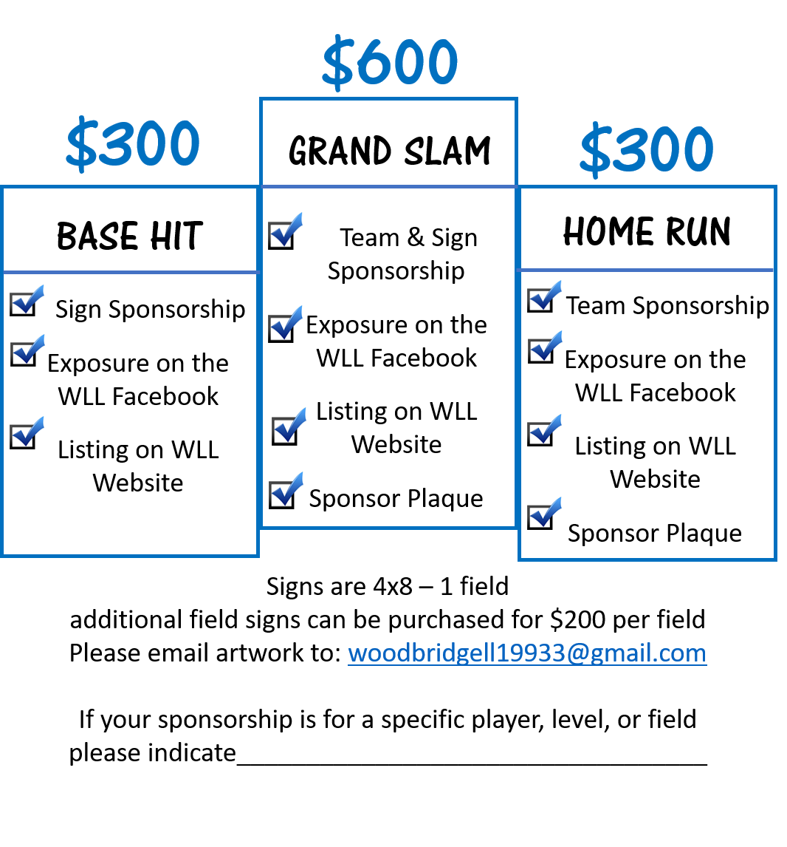

Yes, I would like to be a…
Base Hit Sponsor
Home Run Sponsor
Grand Slam Sponsor
Make a Donation

Business Name: ___________________________
Contact Name: ____________________________
Email: ___________________________________
Phone #: _________________________________
Website: _________________________________
Woodbridge Little League
P.O. Box 29
Bridgeville DE 19933
Make check payable to: Woodbridge Little League

Have a question or request?
Shelly McCarron 302-542-6273
Email woodbridgell19933@gmail.com

